Project Proposal

Mobile Application: Android

Myriam E., Zeena N.

02/09/24

Project Idea/Concept: Mobile Language Learning Platform

**Business Description:**

In today's globalized world, there is an increasing need for accessible and engaging language learning solutions. This is why WordWave is a virtual language learning platform. Effective language learning resources are now more important than ever as companies grow globally and people look for possibilities overseas. WordWave provides a dynamic and immersive virtual learning environment in an effort to meet this demand.

**Identified Need:**

Finding interesting and useful materials that suit a variety of learning styles is a challenge for many language learners, as evidenced by in-depth market research and user interviews. Conventional approaches frequently don't provide context from the real world or have any interaction, which discourages students and reduces retention. It is often difficult for people with hectic schedules to commit to strict lesson schedules or travel to language centers.

**Solution:**

Using virtual reality technology, WordWave can develop an immersive and adaptable learning environment. In real-life settings catered to their interests and skill level, learners can engage in real-life interactions, explore virtual cities, and communicate with automated virtual speakers. The program uses gamification components, such quests and incentives, to keep users engaged and efficiently monitor their progress.

Learners can converse with AI-driven characters or other users through speech recognition and natural language processing, getting immediate feedback and corrections.

WordWave offers a range of courses, exercises, and cultural insights tailored to the interests of each user, accommodating different learning styles.

**Model of Revenue:**

WordWave has a subscription-based business strategy and offers membership options in multiple tiers with different features and access levels. Free trials could be determined (30 days)

**Key Features:**

Personalized Learning Profiles: Users can create personalized profiles that track their language proficiency, learning goals, and preferred learning methods.

Progress Tracking: WordWave stores user data, including completed lessons, quiz scores, and interactive session logs, to provide comprehensive progress reports and personalized feedback.

Adaptive Content: Leveraging stored user data, the platform dynamically adjusts lesson content, difficulty levels, and learning pathways to optimize the learning experience for each user.

Data-Driven Insights: WordWave analyzes user data to identify learning patterns, trends, and areas for improvement, enabling continuous optimization of the platform's features and content offerings.

**Data Persistence:**

Data persistence is essential for WordWave to deliver a personalized and adaptive learning experience. By storing user data securely, the platform can track progress, analyze patterns, ultimately enhancing user engagement and learning outcomes. Additionally, data persistence enables synchronization across devices and ensures that users can access their learning history and preferences.

In summary, WordWave seeks to transform language learning by fusing technology with immersive experiences, eventually enabling users to speak fluently and effectively in a worldwide society.

Wireframe: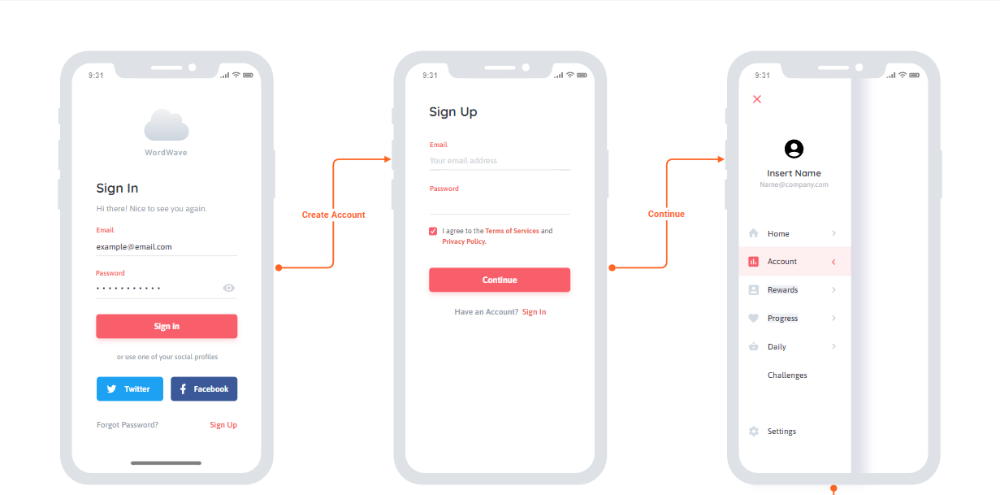

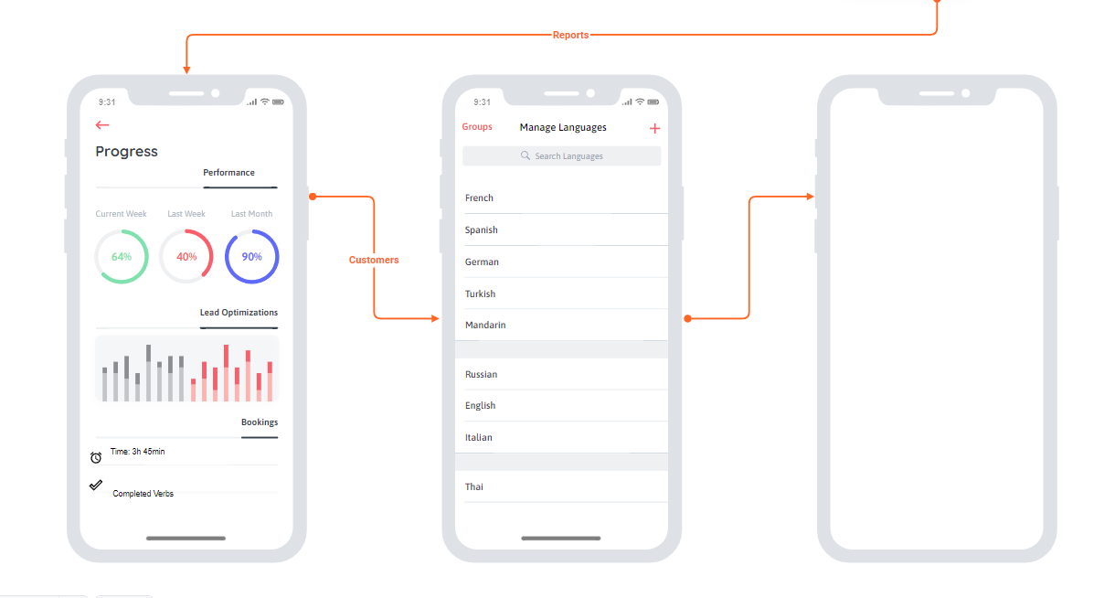

Github link: <https://github.com/myriame2/test.git>